**CS5590 WEB-CLOUD-MOBILE PROGRAMMING**

**ASSIGNMENT – 2**

**By:**

**Adarsh Mergoju**

**ID: 16246333**

**News App**

This web application enables the user to search the BBC News feed and produce results according to a simple keyword search. The search algorithm is done using the BBC API key provided from their server.

* The user needs to first register onto the web application through the registration page.

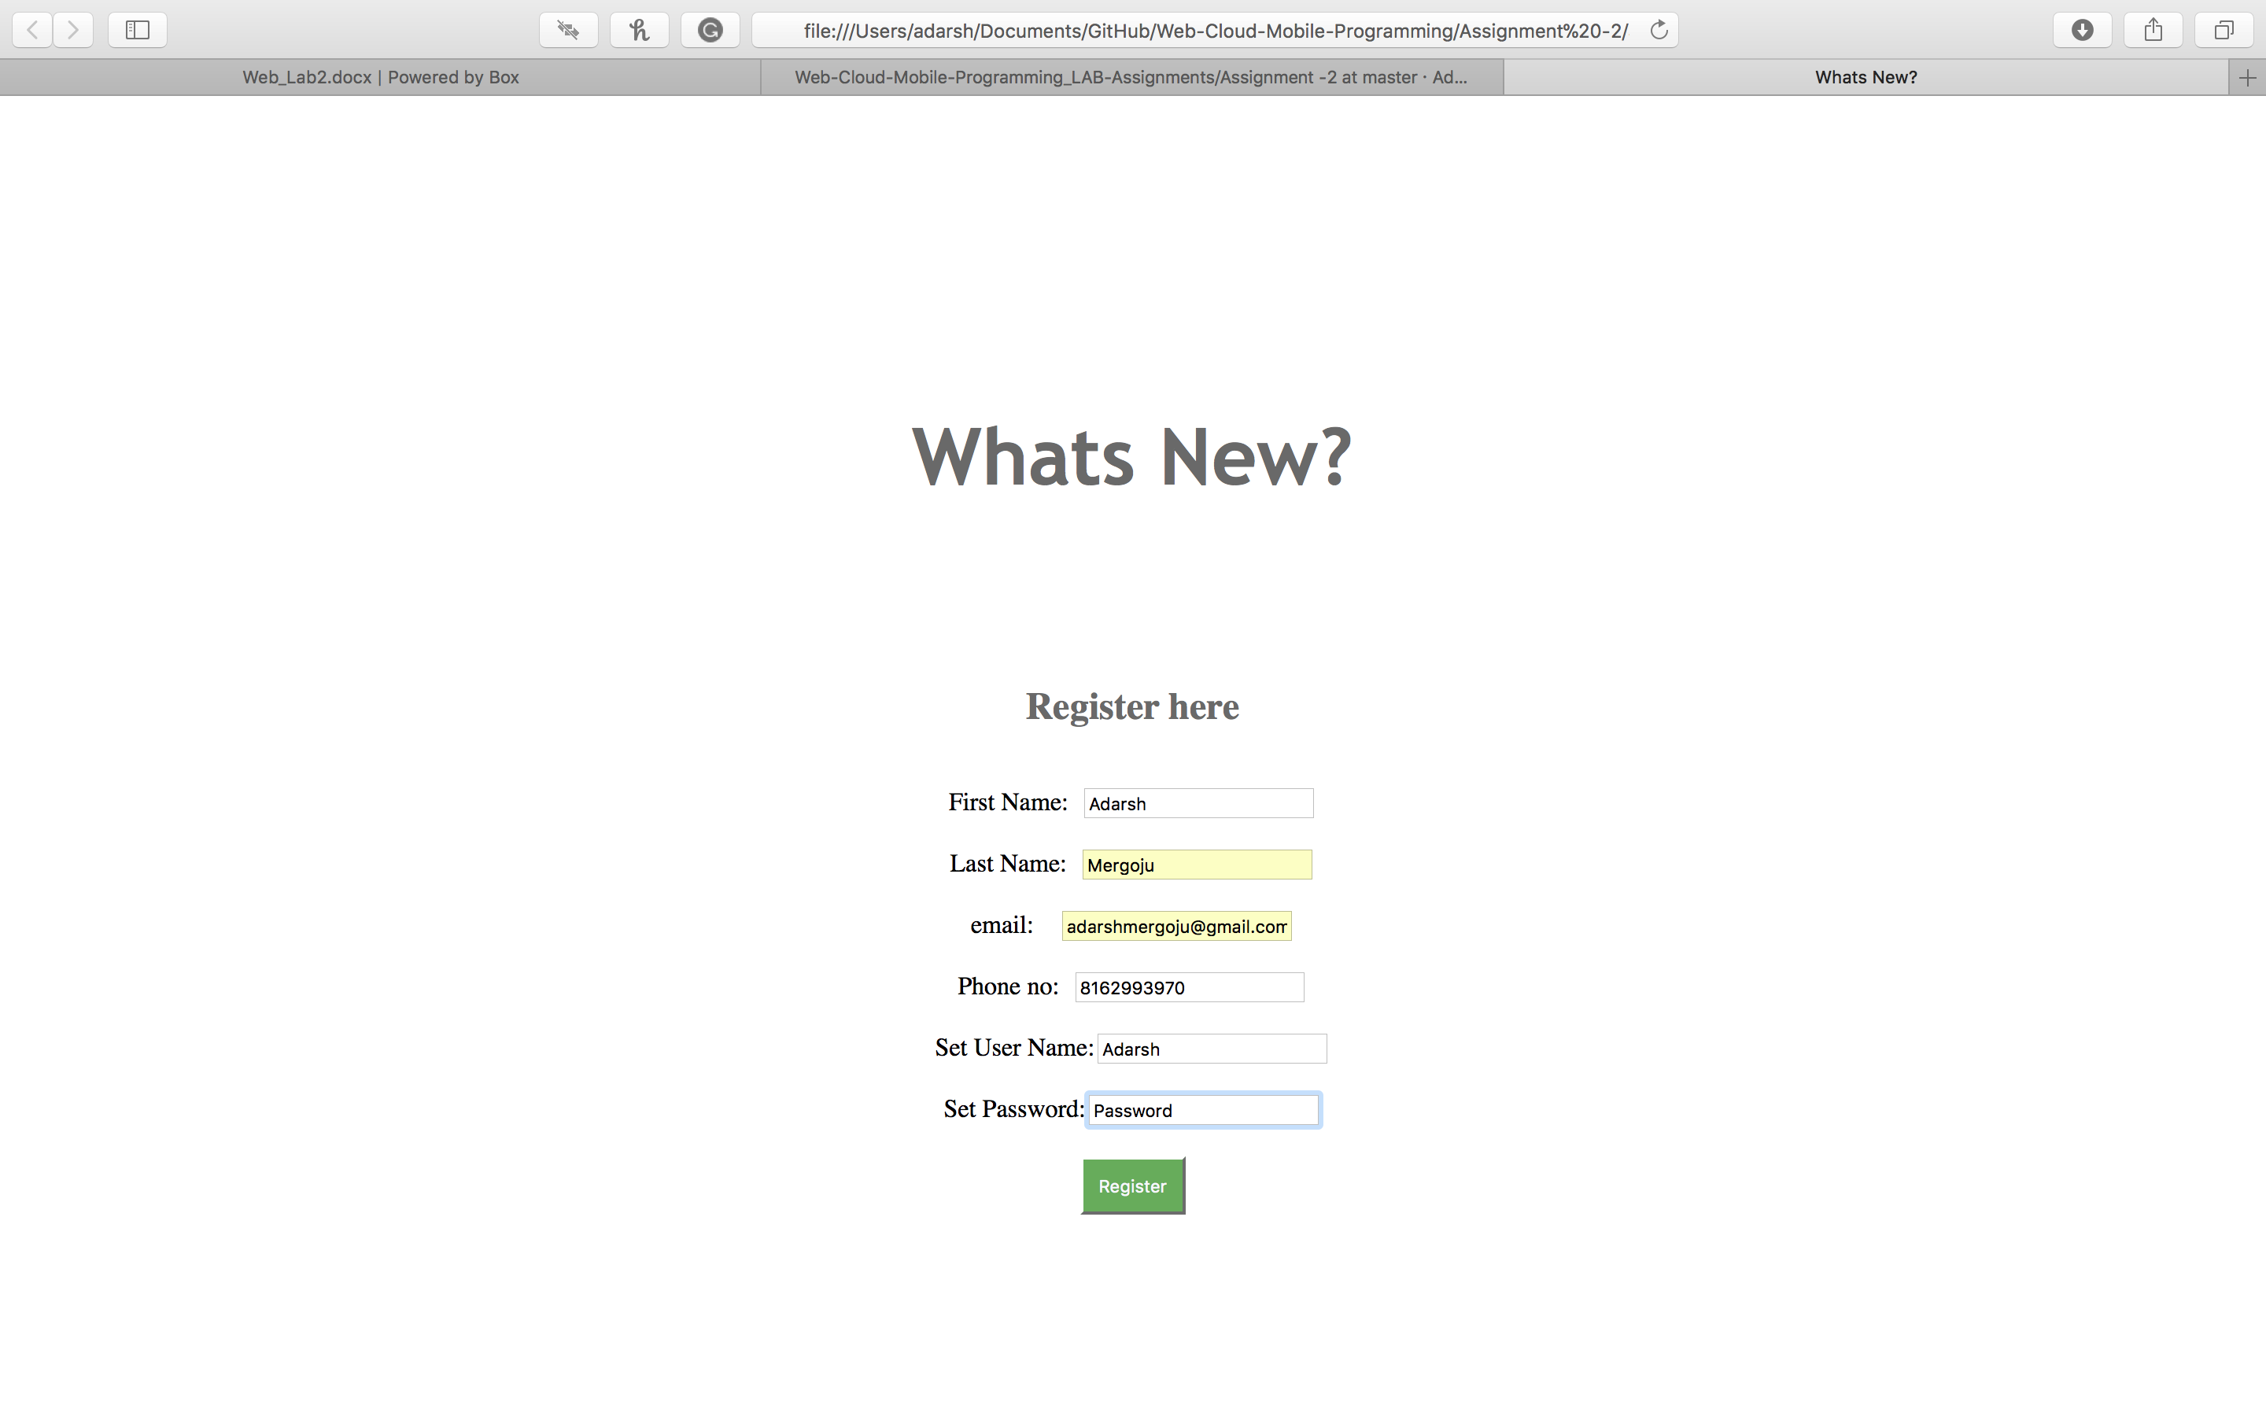

* The user is then redirected to a login page.

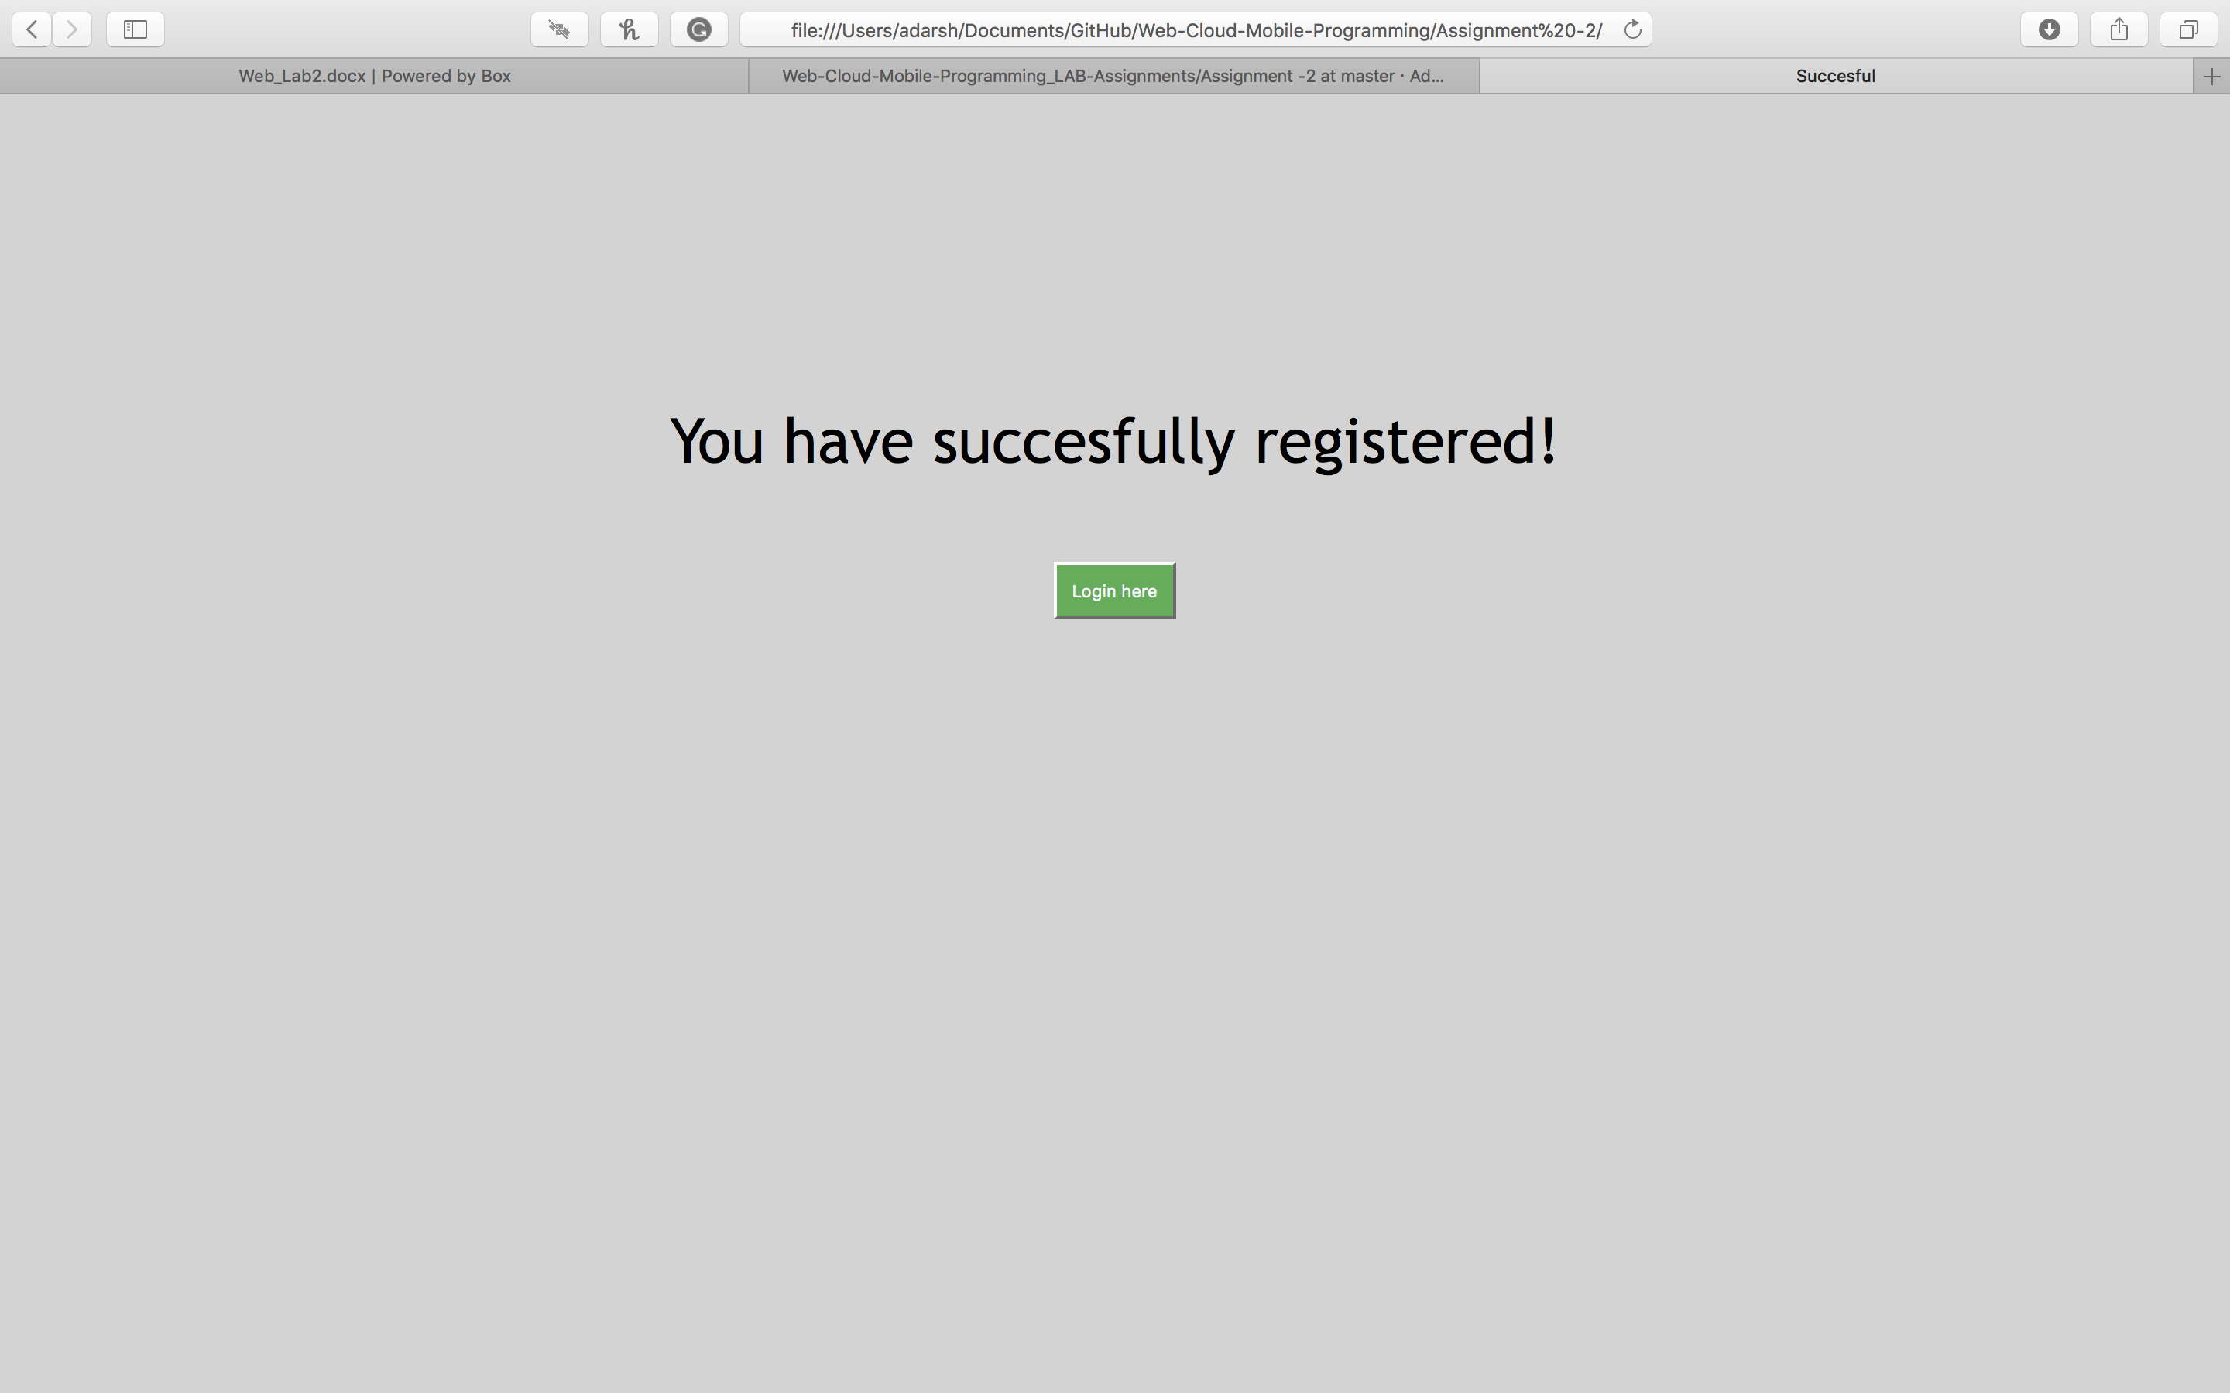

* After entering your details, the user gets logged in to the web application to perform the search.

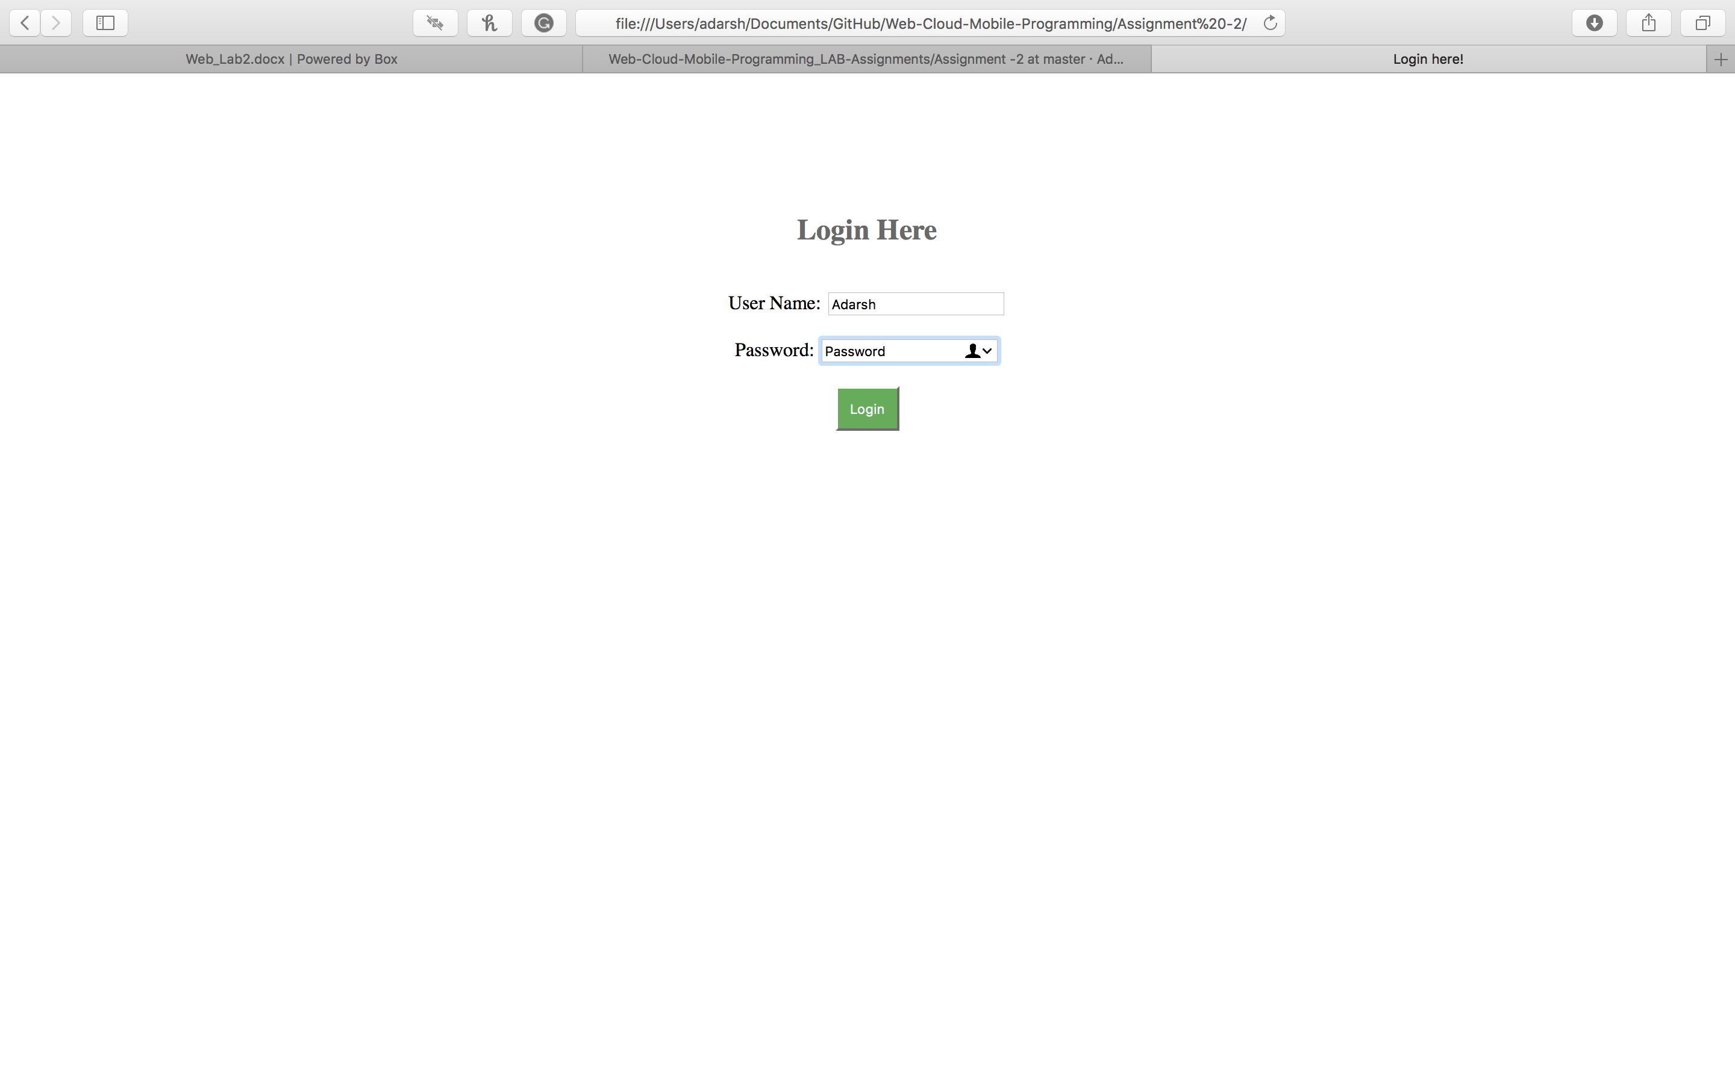

* The web application then displays the list of items it gathers from the server using the API.

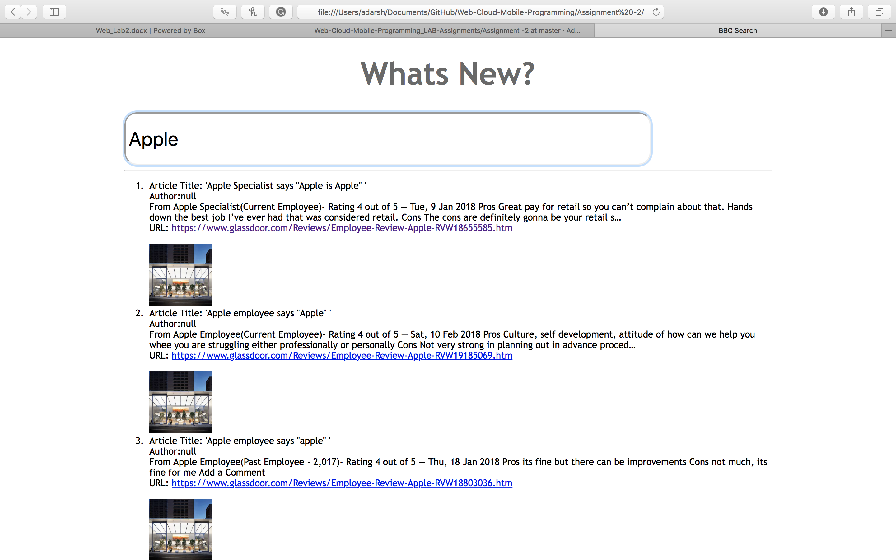

**TIC TAC TOE**

This application was developed using on the AngularJS library. It is a simple simulation of the popular game tic-tac-toe.

* The user is taken to a home page initially.

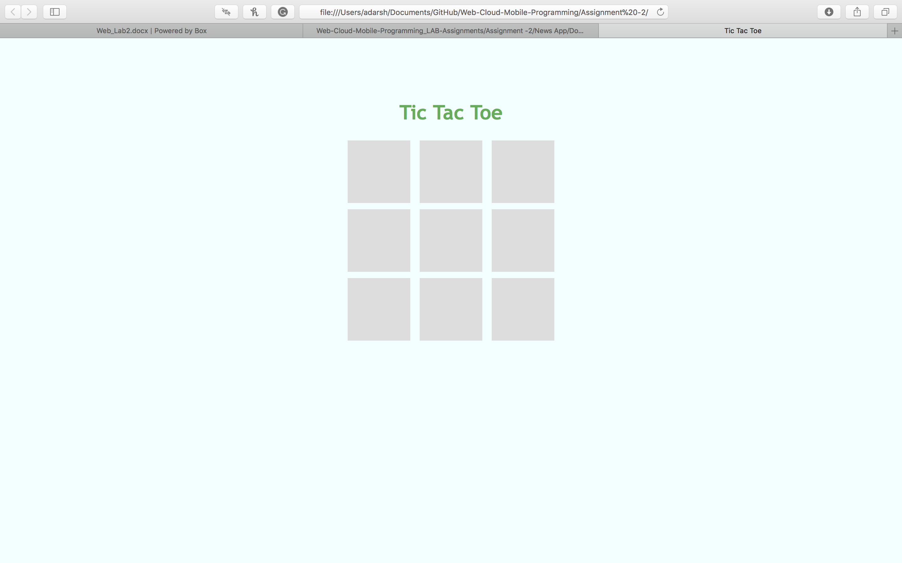

* The gameplay is based on the user’s choice based on which the system’s AI responds.

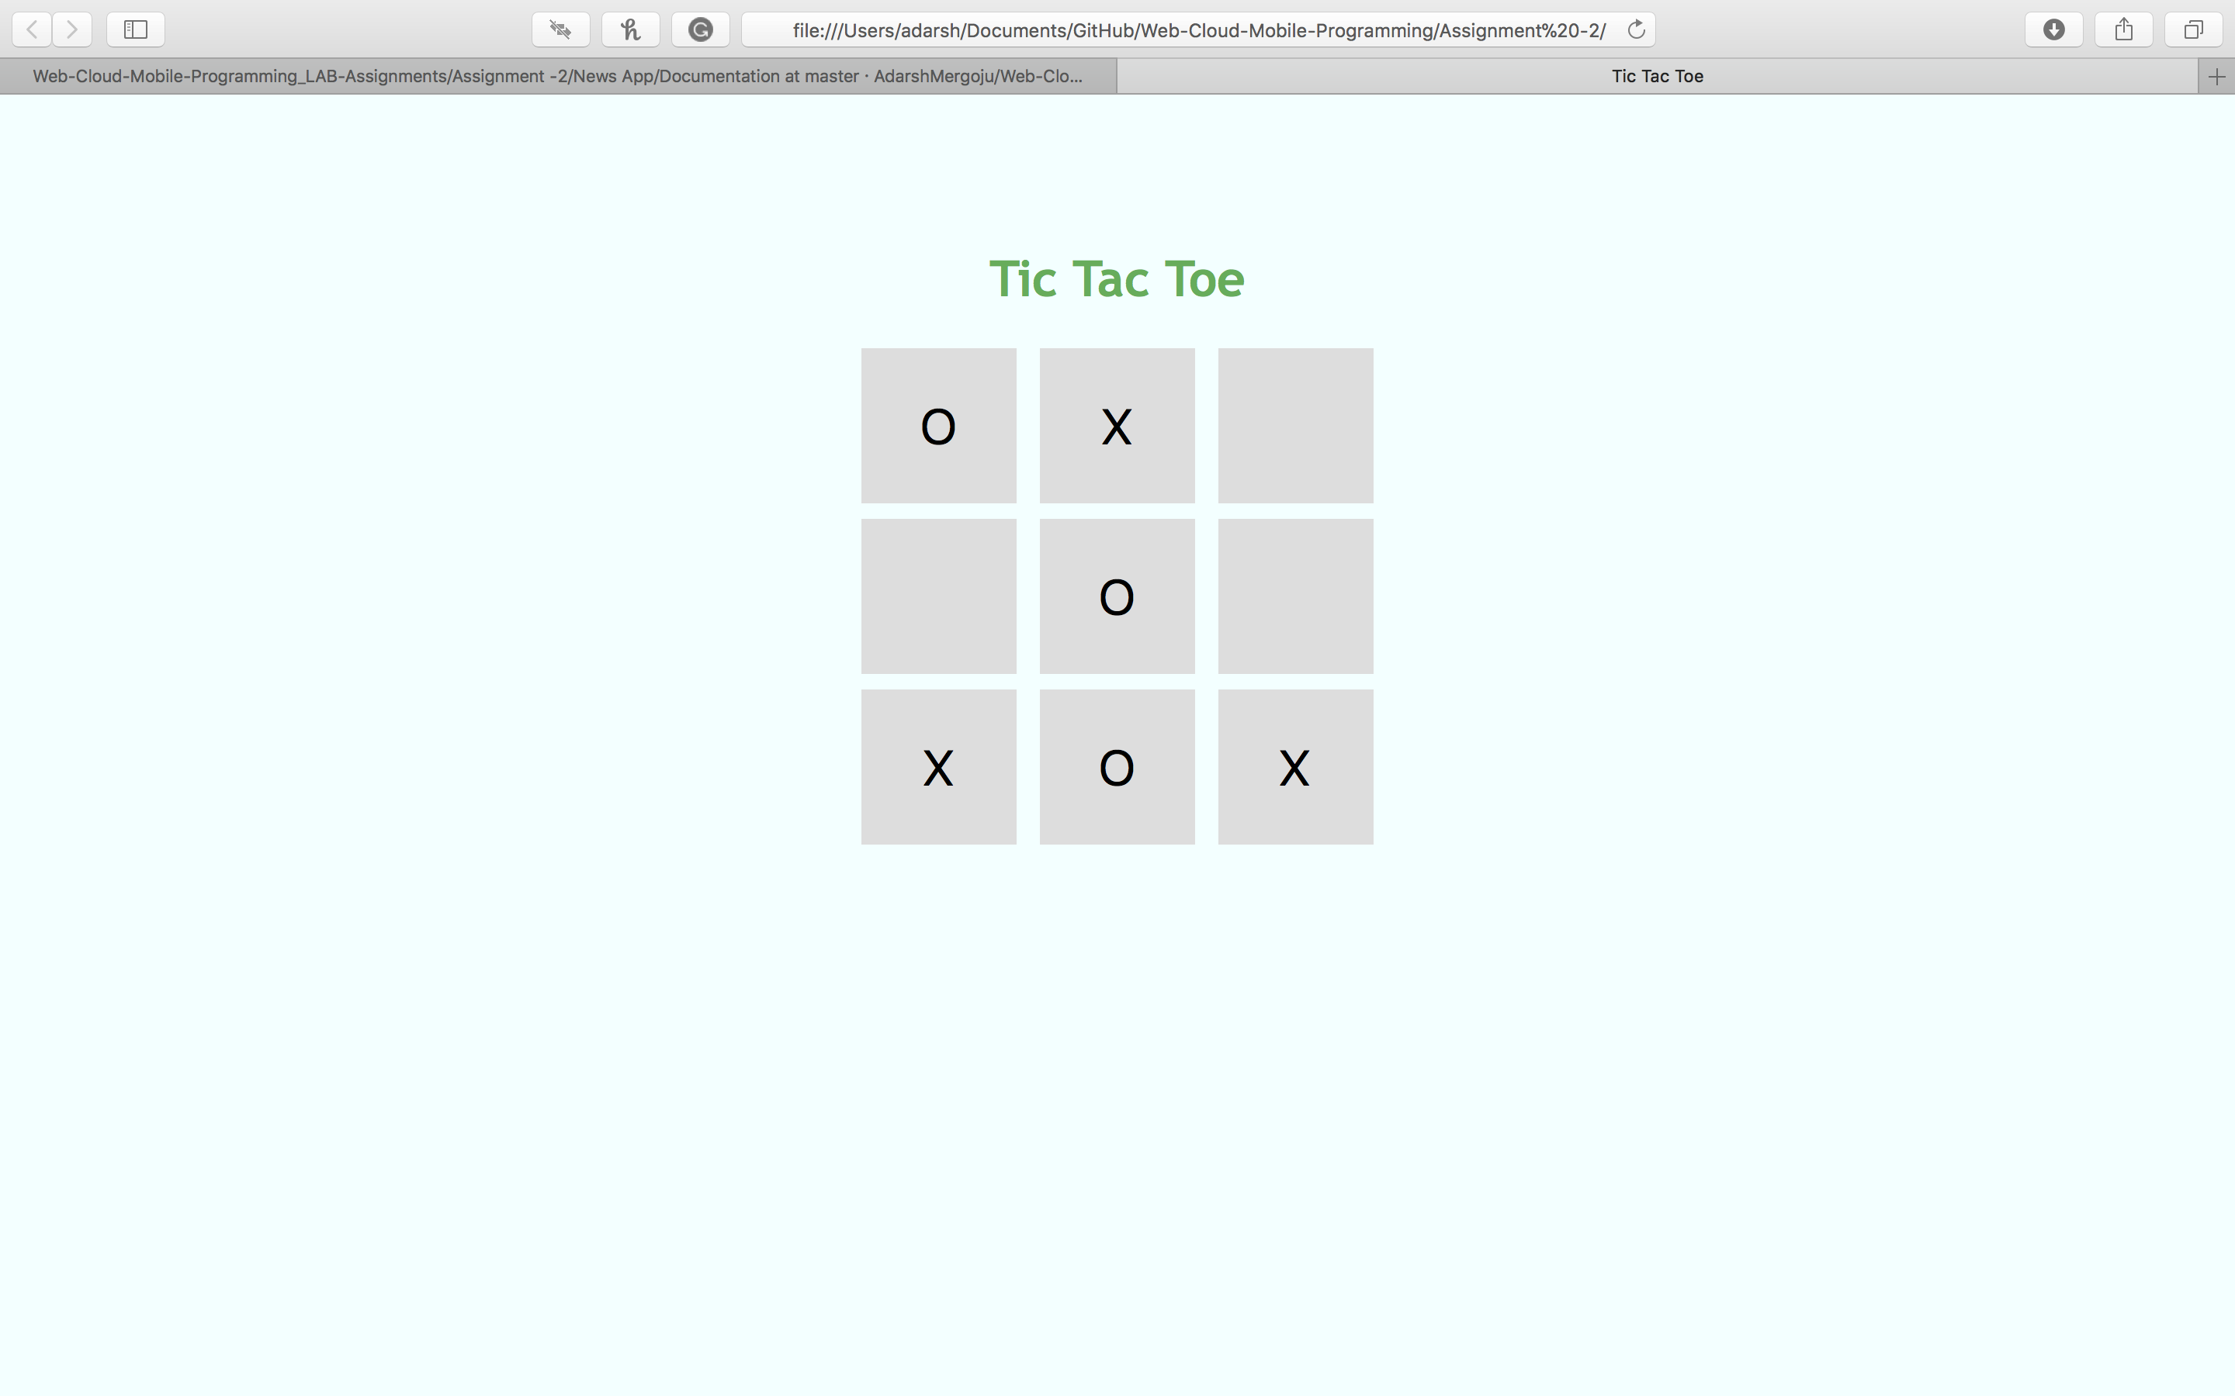

* Upon the end of the game, the browser alerts the user of the result.

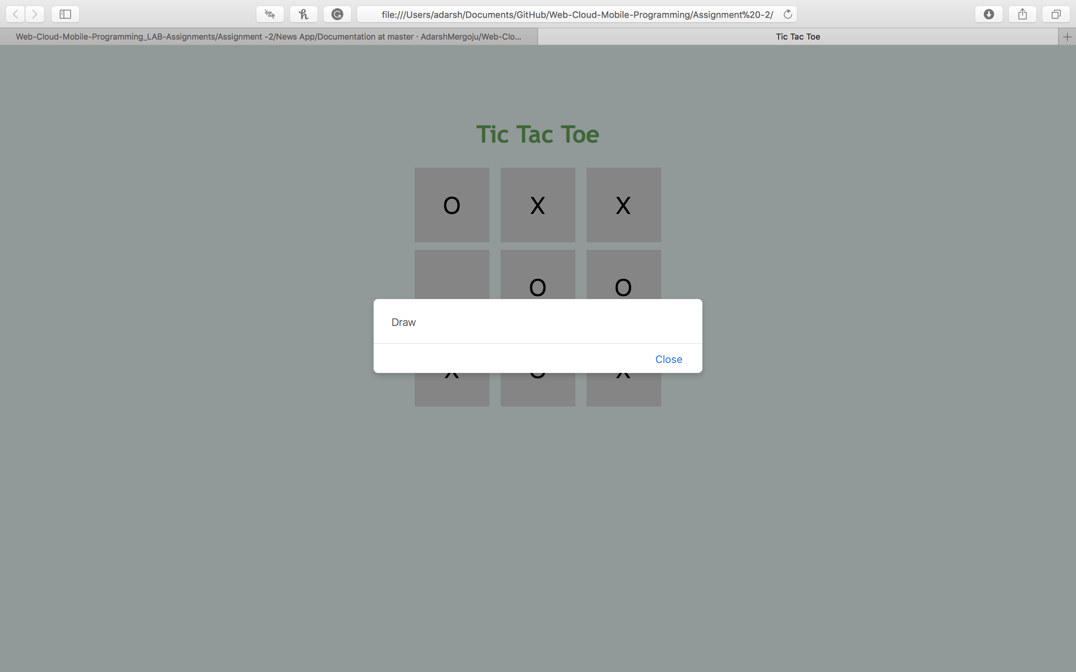

The code uploaded in the GitHub can be found herewith:

News App: https://github.com/AdarshMergoju/Web-Cloud-Mobile-Programming_LAB-Assignments/tree/master/Assignment%20-2/News%20App/Source

Tic Tac Toe: https://github.com/AdarshMergoju/Web-Cloud-Mobile-Programming_LAB-Assignments/tree/master/Assignment%20-2/Tic%20Tac%20Toe